**HTML Basics**

* **Basics**
  + HTML is a standard markup language for creating webpages.
  + HTML stands for Hyper Text Markup Language.
  + HTML describes the structure of web pages using markup
  + HTML elements are building blocks of HTML pages
  + HTML elements are represented by tags

**Example:**

|  |
| --- |
| <!DOCTYPE html> <html> <head> <title>Page Title</title> </head> <body>  <h1>My First Heading</h1> <p>My first paragraph.</p>  </body> </html> |

* + <!DOCTYPE html> 🡪 Defines this document to be HTML 5
    - It represents document type and helps browser to display web pages correctly
    - It must only appear once, at the top of page and it is not case sensitive
  + <html> 🡪 element is the root element of HTML page and it defines the whole document.
  + <head> 🡪 element contains meta information about the document
  + <title> 🡪 element specifies a title for the document
  + <body> 🡪 element contains the visible page content and it defines the document body.
  + <h1> 🡪 element defines a large heading and it defines the heading
  + <p> 🡪 element defines a paragraph
* **HTML Tags/Elements**
  + HTML tags are elements names surrounded by angle brackets.
  + HTML tags normally comes in pairs like <p> and </p>
  + First tag in a pair is start tag and second tag is end tag
  + The end tag is written like start tag, but with forward slash is inserted before the tag name.
  + HTML tags are not case sensitive, means <p> is same as <P>
  + </> If we forgot to add end tag, it will produce unexpected results and/or errors.
* **Empty Elements**
  + HTML elements with no content are called empty elements
  + <br> is an empty element without a closing tag(the <br> tag defines a line break).
* **HTML Attributes**
  + All HTML elements can have attributes
  + Attributes provides additional information about HTML elements.
  + Attributes are always specified in start tag
  + Attributes usually come in name/value paire: **name=”value”**

**Examples:**

* + **The href Attribute**
    - HTML elements are defined with the <a> tag. The link address is specified in the **href** attribute

<a href="https://www.google.com">This is a link</a>

* + **The src Attribute**
    - HTML images are defined in <img> tag
    - The file name of the image source is specified in the src attribute.

<img src="img_girl.jpg">

* + **The width and height Attribute**
    - Images in HTML have a set of size attributes, which specifies the width and height of the image:

<img src="img_girl.jpg" width="500" height="600">

* + **The alt Attribute**
    - The alt attribute specifies an alternative text to be used, when an image cannot be displayed.

<img src="img_girl.jpg" alt="Girl with a jacket">

* + - The alt attribute is also useful if the image does not exists.
  + **The style Attribute**
    - The style attribute is used to specify the styling of an element like, color, font, size, etc.

<p style="color:red">I am a paragraph</p>

* + **The lang Attribute**
    - The language of the document can be declared in the <html> tag
    - The language is declared with lang attribute

|  |
| --- |
| <!DOCTYPE html> **<html lang="en-US">** <body>  ...  </body> </html> |

* + - The first two letters specify language(**en).** If there is dialect, use two more letters (**US).**
  + **The title Attribute**
    - The value of the title attribute will be displayed as a tooltip when mouse over the element.

|  |
| --- |
| <p title="I'm a tooltip"> This is a paragraph. </p> |

* + **Single/Double Quotes for Attribute?**
    - Double quotes around attribute values are the most common in HTML, but single quotes can also be used.
    - In some situations, when the attribute value itself contains double quotes, it is necessary to use single quotes.

<p title='John "ShotGun" Nelson'>

* + - Or vice versa

<p title="John 'ShotGun' Nelson">

* **HTML Headings**
  + HTML headings are defined with <h1> to <h6> tags.
  + <h1> defines the most important heading.
  + <h6> defines the least important heading.

**Note:** Browsers automatically add some white space( a margin) before and after heading

* + Each HTML heading has a default size. However, we can specify the size for any heading with the

style attribute, using the CSS font-size property

<h1 style="font-size:60px;">Heading 1</h1>

* **HTML Horizontal Rules**
  + The <hr> tag defines a thematic break in an HTML page, and is most often displayed as a horizontal rule.
  + The <hr> element is used to separate content in an HTML page.

|  |
| --- |
| **This is heading 1**  This is some text.  **This is heading 2**  This is some other text.  **This is heading 2**  This is some other text. |

* **HTML <head> element**
  + The **<head>** element is a container for metadata.
  + HTML metadata is data about the document.
  + Metadata is not displayed over the HTML page.
  + The <head> element is placed between the <html> tag and the <body> tag:

|  |
| --- |
| <!DOCTYPE html> <html>  <head>   <title>My First HTML</title>   <meta charset="UTF-8"> </head>  <body> . . . |

* **HTML <p> Paragraphs**
  + The HTML <p> element defines the paragraphs.
  + Browsers automatically add some white space (a margin) before and after a paragraph.

|  |
| --- |
| <p>This is a paragraph.</p> <p>This is another paragraph.</p> |

* **HTML Display**
  + We cannot be sure how HTML will be displayed.
  + Large or small screens, and resized windows will create different results.
  + With HTML, we cannot change the output by adding extra space or extra lines in our HTML code.
  + The browser will remove if any extra space or extra lines when the page is displayed.

|  |  |
| --- | --- |
| <p> This paragraph contains a lot of lines in the source code, but the browser  ignores it. </p>  <p> This paragraph contains         a lot of spaces in the source         code, but the        browser  ignores it. </p> | This paragraph contains a lot of lines in the source code, but the browser ignores it.  This paragraph contains a lot of spaces in the source code, but the browser ignores it.  The number of lines in a paragraph depends on the size of the browser window. If you resize the browser window, the number of lines in this paragraph will change. |

* **HTML Line Breaks**
  + The HTML **<br>** elements defines a line break.
  + Use **<br>** if we want line break without starting a new paragraph.

|  |  |
| --- | --- |
| <p>This is<br>a paragraph<br>with line breaks.</p> | This is a paragraph with line breaks |

* **HTML <pre> element**
  + The HTML <pre> element defines preformatted text.
  + The text inside <pre> element is displayed in a fixed-width font, and it preserves both spaces and line breaks.

|  |  |
| --- | --- |
| <pre>   My Bonnie lies over the ocean.    My Bonnie lies over the sea.    My Bonnie lies over the ocean.    Oh, bring back my Bonnie to me. </pre> | The pre tag preserves both spaces and line breaks:  My Bonnie lies over the ocean.  My Bonnie lies over the sea.  My Bonnie lies over the ocean.    Oh, bring back my Bonnie to me. |

* **HTML style Attribute**
  + Setting the style of an HTML element, can be done with the style attribute.
  + **Syntax:**

|  |
| --- |
| <tagname style="property:value;"> |

* + The property is a CSS property.
  + The value is a CSS value.
  + **background-color**, **color**, **font-family**, **font-size**, **text-align** are some style properties.
* **HTML Formatting Elements**
  + Apart from style attribute, HTML also defines some special elements for defining text with special meaning.
  + HTML uses elements like <b> and <i> for formatting output, like **bold** and *italic* text.
  + Formatting elements were designed to display special types of text:
    - <b> - Bold text
    - <strong> - Important text
    - <i> - Italic text
    - <em> - Emphasized text
    - <mark> - Marked text
    - <small> - Small text
    - <del> - Deleted text
    - <ins> - Inserted text
    - <sub> - Subscript text
    - <sup> - Superscript text
  + HTML <b> and <strong> both elements displays the same output, <b> element defines **bold** text without any extra importance and <strong> element defines **strong** text with added semantic importance.
  + HTML <i> and <em> both elements displays the same output, <i> element defines *italic* text without any extra importance and <em> element defines *emphasized* text with added semantic importance.
  + HTML <small> element defines smaller text

|  |  |
| --- | --- |
| <h2>HTML <small>Small</small> Formatting</h2> | HTML Small Formatting |

* + HTML <mark> element defines marked or highlighted text

|  |  |
| --- | --- |
| <h2>HTML <mark>Marked</mark> Formatting</h2> | HTML Marked Formatting |

* + HTML <del> element defines ~~deleted~~(removed) text

|  |  |
| --- | --- |
| <p>My favorite color is <del>blue</del> red.</p> | My favorite color is ~~blue~~ red. |

* + HTML <ins> element defines inserted (added) text

|  |  |
| --- | --- |
| <p>My favorite <ins>color</ins> is red.</p> | My favorite color is red.. |

* + HTML <sub> element defines subscripted text

|  |  |
| --- | --- |
| <p>This is <sub>subscripted</sub> text.</p> | This is subscripted text. |

* + HTML <sup> element defines superscripted text

|  |  |
| --- | --- |
| <p>This is <sup>subscripted</sup> text.</p> | This is superscripted text. |

* **HTML Quotation and Citation Elements**
  + HTML <q> elements defines a short quotation. Browser usually insert quotation marks around the <q> element.

|  |  |
| --- | --- |
| <p>WWF's goal is to: <q>Build a future where people live in harmony with nature.</q></p> | WWF's goal is to: “Build a future where people live in harmony with nature.” |

* + HTML <blockquote> elements defines a section that is quoted from another source.

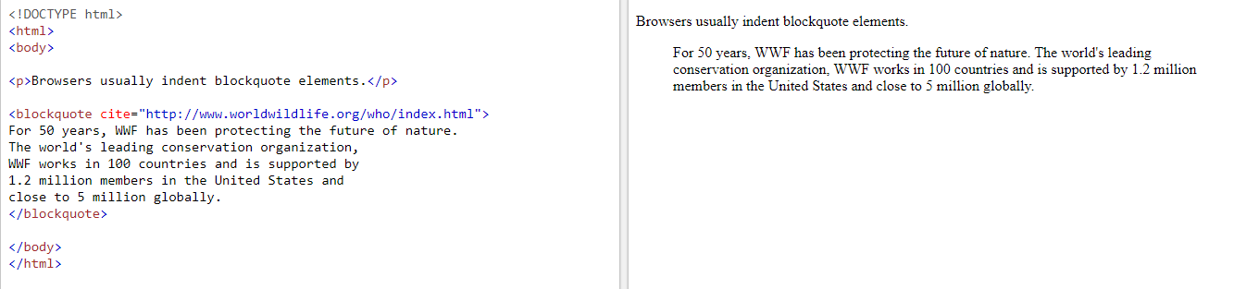

* + HTML <abbr> elements defines an abbreviation of an acronym.

|  |  |
| --- | --- |
| <p>The <abbr title="World Health Organization">WHO</abbr> was founded in 1948.</p> | The WHO was founded in 1948. |

* + <address>
    - This element defines contact information(author/owner) of a document or an article.
    - This is usually displayed in italic. Most browsers will add a line break before and after the element.

|  |  |
| --- | --- |
| <address> Written by John Doe.<br>  Visit us at:<br> Example.com<br> Box 564, Disneyland<br> USA </address> | *Written by John Doe. Visit us at: Example.com Box 564, Disneyland USA* |

* + <cite>
    - This element defines the title of a work.
    - Browsers usually displays <cite> elements in italic.

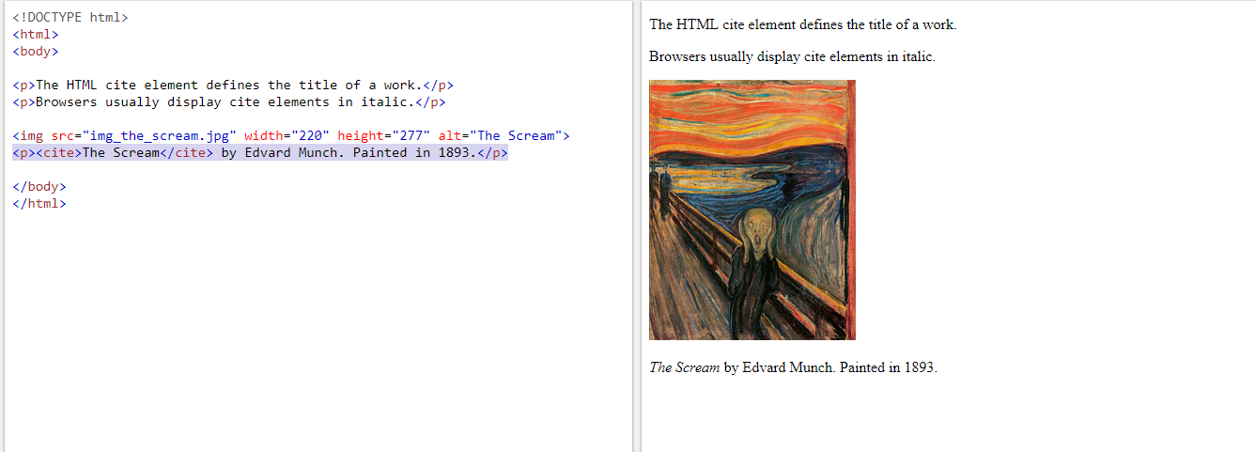

* + <bdo>
    - This element defines bi-directional override.
    - The <bdo> element is used to override the current text direction.

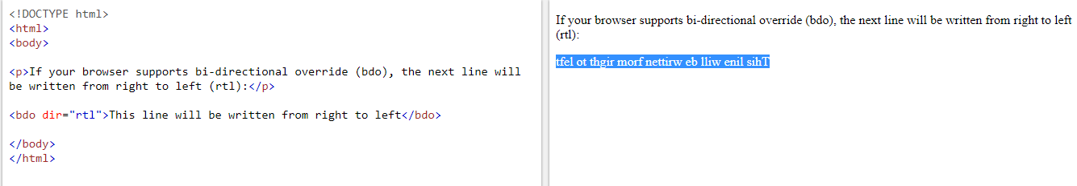

* + **HTML Comments**
    - We can add comments to our **HTML source** by using the following syntax.

<!-- Write your comments here -->

* + **HTML Colors**
    - HTML colors are specified using predefined color names, or RGB, HEX, HSL, RGBA, HSLA values.
    - In HTML a color can be specified by using a color name.

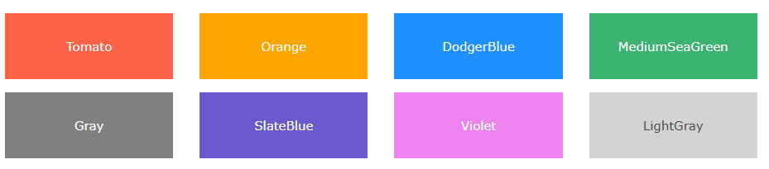

* + - **Background color**
      * We can set the background color for HTML elements.

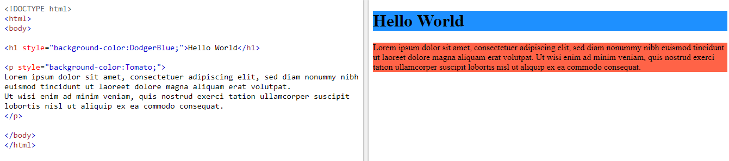

* + - **Text color**
      * We can set the color of the text

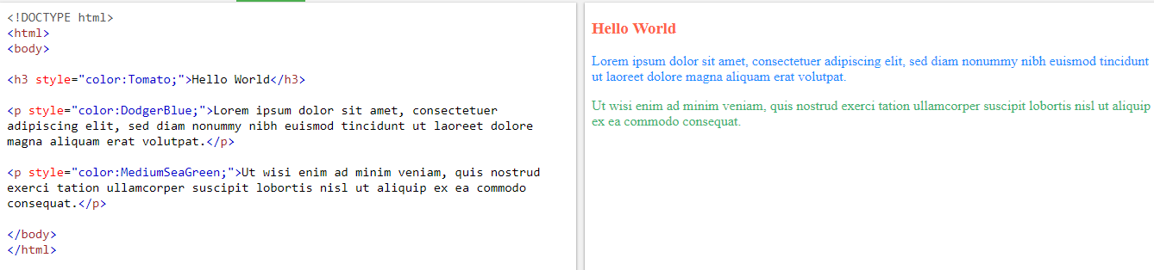

* + - **Border color**
      * We can set the color of borders.

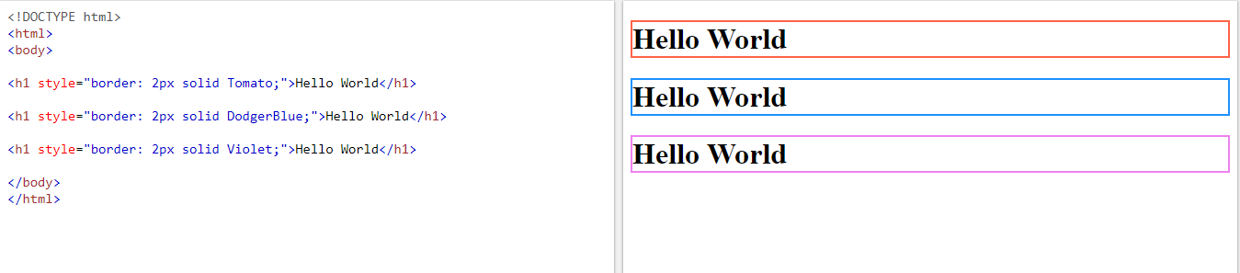

* + - **Color values**
      * In HTML, colors can also be specified using RGB values, HEX values, HSL values, RGBA values and HSLA values:

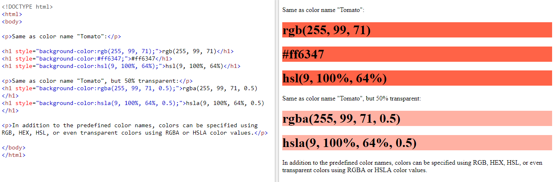

* + - **RGB Value**
      * In HTML a color can be specified as an RGB value, using this formula.

**rgb(red, green, blue)**

* + - * Each parameter (red, green, blue) defines the intensity of the color between 0 and 255.
      * For Example, rgb(255, 0 ,0 ) is displayed as red, because red is set to its highest value(255) and the others are set to 0.
      * To display the color black, all color parameters are set to 0 like this: rgb(0,0,0)
      * To display the color white, all color parameters are set to 255 like this: rgb(255,255,255)
    - **HEX Value**
      * In HTML, a color can be specified using a hexadecimal value in the form:

**#rrggbb**

* + - * Where rr (red), gg (green) and bb (blue) are hexadecimal values between 00 and ff (same as decimal 0 and 255).
      * For Example, #ff0000 is displayed as red, because red is set to its highest value (ff) and the others are set to the lowest value(00).
    - **HSL Value**
      * In HTML, a color can be specified using hue, saturation, and lightness (HSL) in the form.

**hsl(hue, saturation, lightness)**

* + - * Shades of gray are often defined by setting the hue and saturation to 0, and adjust the lightness from 0% to 100% to get darker or lighter shades.
      * **Hue**
        + Hue is a degree on the color wheel from 0 to 360. 0 is red, 120 is green, 240 is blue.
      * **Saturation** 
        + It is a percentage value, 0% means a shade of gray, and 100% is the full color.
        + Saturation can be described as the intensity of a color.
        + 100% is pure color, no shades of gray.
        + 50% is 50% gray, but you can still see the color.
        + 0% is completely gray, you can no longer see the color.
      * **Lightness**
        + It is also a percentage, 0% is black, 50% is neither light or black, 100 % is white.
        + The lightness of the color can be described as how much light you want to give the color, where 0% means no light(black), 50% means 50% light (neither dark nor light), 100% means full lightness.
    - **RGBA Value**
      * RGBA color values are an extension of RGB color values with an alpha channel – which specifies the opacity for a color.
      * An RGBA color values is specified with

**rgba(red, green, blue, alpha)**

* + - * The alpha parameter is a number between 0.0 (fully transparent) and 1.0 (not transparent at all).
    - **HSLA Value**
      * HSLA color values are an extension of HSL color values with an alpha channel – which specifies the opacity for a color.
      * An HSLA color values is specified with

**hsla(hue, saturation, lightness, alpha)**

* + - * The alpha parameter is a number between 0.0 (fully transparent) and 1.0 (not transparent at all).
  + **HTML Links – Hyperlinks**
    - HTML links are hyperlinks.
    - You can click on a link and jump to another document.
    - When you move the mouse over a link, the mouse arrow will turn into a little hand.
    - In HTML, links are defined with the <a> tag

|  |
| --- |
| <a href="*url*">*link text*</a> |

* + - The **href** attribute specifies the destination address(<https://www.google.com/>) of the link.
    - The link text is the visible part, clicking on the link text will send you to the specified address.
      * NOTE: Without forward slash at the end of the address, you might generate two request to the server.
      * Many servers will automatically add a forward slash to the end of the address, and then create new request.
    - **Local links**
      * The example above used an absolute URL (a full web address).
      * A local link (link to the same website) is specified with a relative URL (without https://www....)

|  |
| --- |
| <a href="html_images.asp">HTML Images</a> |

* + - **HTML Links Colors**
      * By default, a link will appear like this (in all browsers).
        + An unvisited link is underlined and blue.
        + A visited link is underlined and purple.
        + An active link is underlined and red.

**You can change the default colors, by using CSS**

|  |
| --- |
| <style> a:link {   color: green;    background-color: transparent;    text-decoration: none; }  a:visited {   color: pink;   background-color: transparent;   text-decoration: none; }  a:hover {   color: red;   background-color: transparent;   text-decoration: underline; }  a:active {   color: yellow;   background-color: transparent;   text-decoration: underline; } </style> |

**Links are often styled as button, by using CSS.**

|  |
| --- |
| <style> a:link, a:visited {   background-color: #f44336;   color: white;   padding: 15px 25px;   text-align: center;   text-decoration: none;   display: inline-block; }  a:hover, a:active {   background-color: red; } </style> |

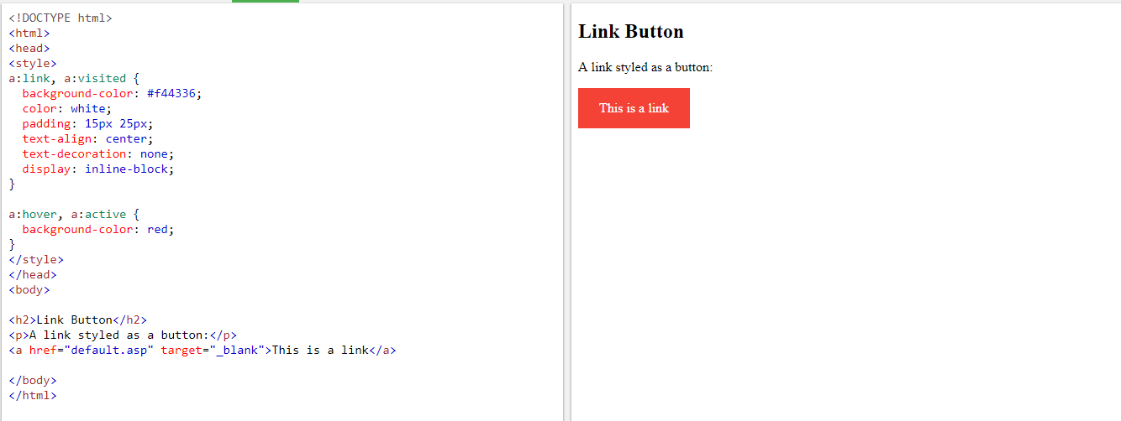

* + - **HTML Links – The target Attribute**
      * The **target** attribute specifies where to open the linked document.
      * The **target** attribute can have the following values.
        + _blank – opens the linked document in a new window or tab
        + _self – opens the linked document in the same window/tab as it was clicked (this is default)
        + _parent – Opens the linked document in the parent frame.
        + _top – Opens the linked document in the full body of the window.
        + framename – Opens a linked document in a named frame.
    - **HTML Links – Images as Link**
      * It is common to use images as link:

|  |
| --- |
| <a href="default.asp">   <img src="smiley.gif" alt="HTMLtutorial" style="width:42px;height:42px;border:0;"> </a> |

* + - **HTML Link – Create a Bookmark**
      * HTML bookmarks are used to allow renders to jump to specific parts of a webpage.
      * Bookmarks can be useful if your webpage is very long.
      * To make a bookmark, we must first create the bookmark, and then add a link to it.
      * When the link is clicked, the page will scroll to the location with the bookmark.

**Example**

First, create a bookmark with id attribute

|  |
| --- |
| <h2 id="C4">Chapter 4</h2> |

* + - * Then add a link to the bookmark, from with the same page.

|  |
| --- |
| <a href="#C4">Jump to Chapter 4</a> |

* + - * Or, add a link to the bookmark, from another page.

|  |
| --- |
| <a href="html_demo.html#C4">Jump to Chapter 4</a> |

* + **HTML Images**
    - Images can improve the design and appearance of the webpage.
    - In HTML, images are defined with the <img> tag.
    - The <img> tag is empty, it contains attributes only, and does not have to closing tag.
    - The src attribute specifies the URL (web address) of the image.

|  |
| --- |
| <img src="*url*"> |

* + - **The alt attribute**
      * The alt attribute provides an alternate text for an image.
      * The value of the alt attribute should describe the image.

|  |
| --- |
| <img src="img_chania.jpg" alt="Flowers in Chania"> |

* + - * If the browser cannot find an image, it will display the value of the alt attribute.
    - **Image Size**
      * You can specify the style attribute to specify the width and height of an image.

|  |
| --- |
| <img src="img_girl.jpg" alt="jack" style="width:500px;height:600px;"> |

* + - * Alternatively, we can use the width and height attribute.

|  |
| --- |
| <img src="img_girl.jpg" alt="jacket" width="500" height="600"> |

* + - * The width and height attributes always defines the width and height of the image in pixels.
    - **Width and Height or Style**
      * The width, height and style attributes are valid in HTML5.
      * However, we suggest using style attribute. It prevents styles sheets from changing the size of the images.

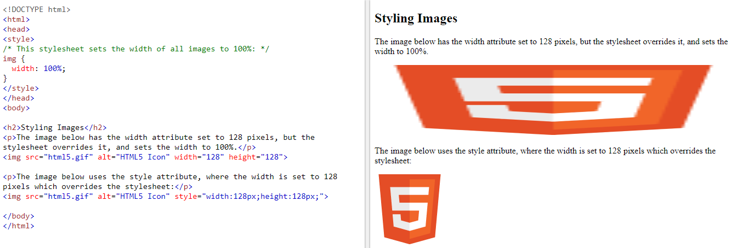

* + - **Images in Another Folder**
      * If not specified, the browser expects to find the image in the same folder as the webpage.
      * However, it is common to store images in sub-folder. You must then include the folder name in the src attribute.

|  |
| --- |
| <img src="/images/html5.gif" alt="HTML5 Icon" style="width:128px;height:128px;"> |

* + - **Images on Another Server**
      * Some web sites store their images on image servers.
      * Actually, we can access images from any web address in the world:

|  |
| --- |
| <img src="https://www.w3schools.com/images/w3schools_green.jpg" alt="W3Schools.com"> |

* + - **Animated Images**
      * HTML allows animated GIFs:

|  |
| --- |
| <img src="programming.gif" alt="Man" style="width:48px;height:48px;"> |

* + - **Images as Link**
      * To use an images as a link, put the <img> tag inside the <a> tag:

|  |
| --- |
| <a href="default.asp">   <img src="smiley.gif" alt="HTML" style="width:42px;height:42px;border:0;"> </a> |

* + - **Image Floating**
      * Use the CSS float property to let the image float to the right or to the left of a text

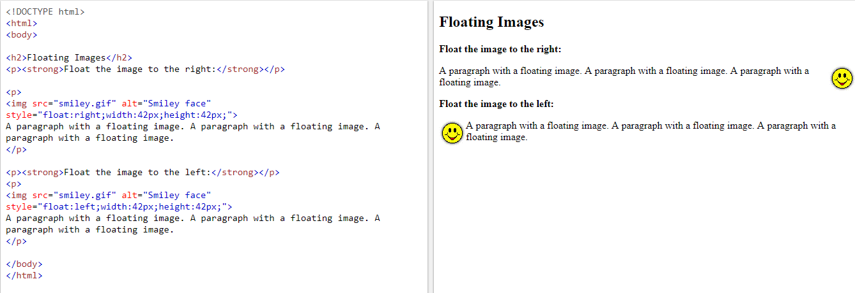

* + - **Image Maps**
      * The <map> tag defines an image-map. An image-map is an image with clickable areas.

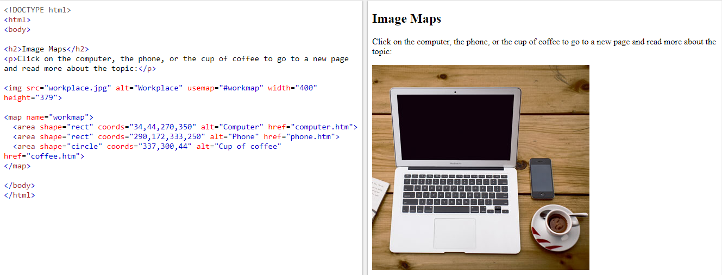

* + - **Image Maps Continuation….**

|  |
| --- |
| <img src="workplace.jpg" alt="Workplace" usemap="#workmap">  <map name="workmap">   <area shape="rect" coords="34,44,270,350" alt="Computer" href="computer.htm">   <area shape="rect" coords="290,172,333,250" alt="Phone" href="phone.htm">   <area shape="circle" coords="337,300,44" alt="Coffee" href="coffee.htm"> </map> |

* + - * The name attribute of the <map> tag is associated with the <img>’s usemap attribute and created a relationship between the image and map.
      * The <map> element contains a number of <area> tags, that define the clickable areas in the image-map.
    - **Background Image**
      * To add a background image on an HTML element, use the CSS property

background-image:

|  |
| --- |
| <body style="background-image:url('clouds.jpg');">  <h2>Background Image</h2>  </body> |

* + - **The <picture> Element**
      * HTML5 introduced the <picture> element to add more flexibility when specifying image resources.
      * The <picture> element contains a number of <source> elements, each referring to different image sources. This way the browser can choose the image that best fits the current view and/or device.
      * Each <source> element have attributes describing when their image is the most suitable.
      * The browser will use the first <source> element with matching attribute values, and ignore any following <source> elements.

|  |
| --- |
| <picture>   <source media="(min-width: 650px)" srcset="img_pink_flowers.jpg">   <source media="(min-width: 465px)" srcset="img_white_flower.jpg">   <img src="img_orange_flowers.jpg" alt="Flowers" style="width:auto;"> </picture> |

* + **HTML Images**
    - **HTML Table – Adding a border**
      * If you don’t specify a border for the table, it will be displayed without borders.
      * A border is set to using CSS property

|  |
| --- |
| table, th, td {   border: 1px solid black; } |

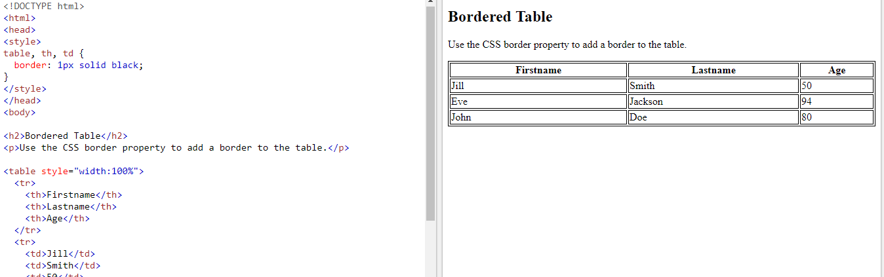

* + - **HTML Table – Collapsed border**
      * If we want the borders to collapse in to one border, add the CSS border-collapse property:

|  |
| --- |
| table, th, td {   border: 1px solid black;   border-collapse: collapse; } |

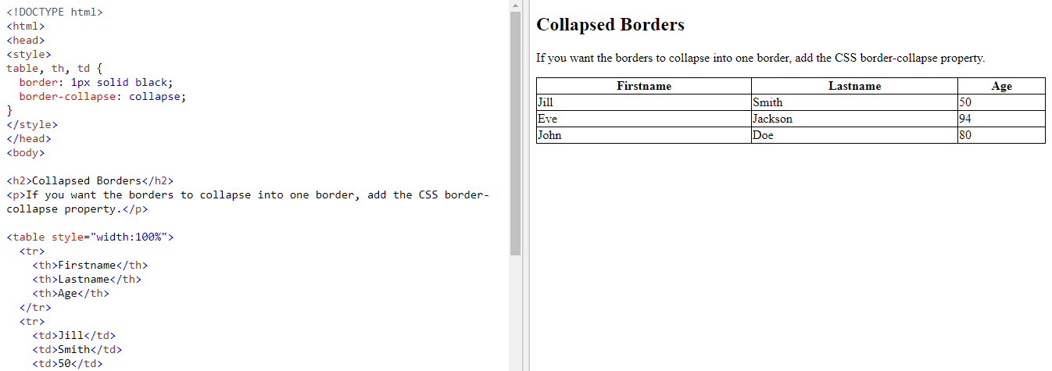

* + - **HTML Table – Adding Cell Padding**
      * Cell padding specifies the space between the cell content and its border.
      * If we don’t specify a padding, the table cells will be displayed without padding.
      * To set the padding, use the CSS padding property.

|  |
| --- |
| th, td {   padding: 15px; } |

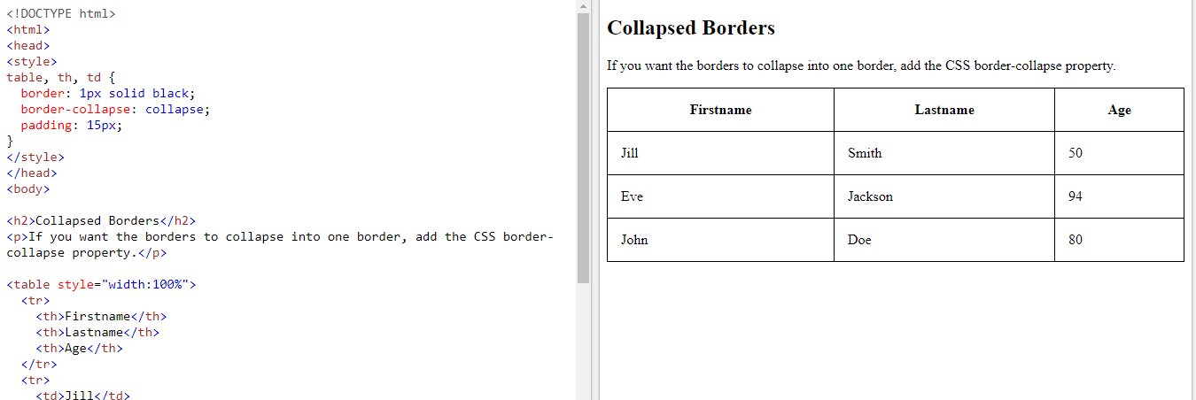

* + - **HTML Table – Adding a Caption**
      * To add a caption to a table, use the <caption> tag.
      * The <caption> tag must be inserted immediately after the <table> tag

|  |
| --- |
| <table style="width:100%">   <caption>Monthly savings</caption>   <tr>     <th>Month</th>     <th>Savings</th>   </tr>   <tr>     <td>January</td>     <td>$100</td>   </tr>   <tr>     <td>February</td>     <td>$50</td>   </tr> </table> |

* + - **A Special Style for One Table**
      * By using id attribute to the table, we can specify the special style for a table.

|  |
| --- |
| <style>  table#t01 {   width: 100%;    background-color: #f1f1c1; }  </style>  <table id="t01">   <tr>     <th>Firstname</th>     <th>Lastname</th>      <th>Age</th>   </tr>   <tr>     <td>Eve</td>     <td>Jackson</td>      <td>94</td>   </tr> </table> |